**Java Programs:**

1. Multiply of two int values and print in decimal
2. Division of 2 numbers and print the exact output  
   Ex: a=15, b=2 then output=7.5
3. Find the given number is even or odd (Using ternary operator, if-else, switch)
4. Find the largest among 2 numbers (Using ternary operator, if-else)
5. Find the largest among 3 numbers
6. Find the smallest among 2 numbers
7. Find the smallest among 3 numbers
8. Program to calculate the simple interest. Output must be exactly calculated value  
   Formula: PTR/100
9. Find the square of the circle, rectangle, square
10. Find the perimeter of the circle, rectangle, square
11. Find the given number is prime or not
12. Find all the even numbers from 1 to n
13. WAP to print Fizz when the number is divisible by only 3, Buzz when divisible by 5 and Fizz Buzz when divisible by both. If not divisible by any of them then print the number, from the sequence of numbers
14. Find all the prime numbers from 1 to n
15. Find the factorial of the given number
16. Find the sum of all the digits of the given number
17. Find the sum of all digits of the given number until the result becomes single digit
18. Reversing the given number  
    Ex. if n=123, o/p=321. If n=-123, then o/p=-321. If n=120, then o/p=21
19. Reverse the number 1534236469
20. Find the number is palindrome or not  
    Ex: n=121. Reverse n, output=121. Now n=output -> Palindrome else not
21. Find the power of the given number
22. Find the given number is armstrong  
    Ex: n=153, calculation=(1^3)+(5^3)+(3^3)=153. So n=calculated value -> Armstrong
23. Find the fibonacci series
24. Find the number is neon number  
    Ex: n=9, square of n=81-> add both the digits from squared value, results 9. So neon number
25. Find the ascii number of the given character
26. Swapping of 2 numbers using 3rd variable
27. Swapping of numbers without using 3rd variable
28. Find the year is leap year
29. Generate the multiplication table of the given number
30. Print A to Z
31. Find all the factors of the given number
32. Find the character is alphabet or not
33. Count the number of digits on the given number
34. Count the number of vowels and consonants in a sentence
35. Removing all the spaces in a sentence
36. Find the occurrence of a given character in the string
37. Remove the duplicate characters present in the string
38. Reversing the string
39. Input: “I love my India”. Output: “India my love I”
40. Input s=”aabbbccccdddda”, output= a:2 b:3 c:4 d:4 a:1
41. Find the pattern repetition in the string  
    Ex: maaamaaahhaaaaa -> Here “aa” is repeated for 8 times
42. Find the string is anagram  
    Ex: **race** and **care**. If we see both the words then all the characters are present in the other string
43. Find all the upper cases in the given string
44. Find all duplicate characters present in the given string
45. Program to make the first character in uppercase
46. Program to make the first character in uppercase in each word in the given sentence
47. Program to make only the first character of each word in lowercase rest all characters in uppercase
48. Calculate the average of all the values present in the array
49. Sort the array
50. Find which all numbers are missing from 0-9 from the given array which holds the value only in between 0-9
51. Find the largest number in the array
52. Find the smallest number from the given array
53. Find all the numbers which are either divisible by 4 or 6 or both from an array
54. Given: [1,0,0,1,2,3,0,4,0].Expected output: [1,1,2,3,4,0,0,0,0]
55. Given: [1,0,0,1,2,3,0,4,0].Expected output: [0,0,0,0,1,1,2,3,4]
56. Given int[] a = {2,2,4,5,6,6,6,2,8}. Output: [2,4,5,6,8]
57. Find the occurrence of all the characters present in the given string
58. Find the first repetitive character in the given string
59. Find the 4th repetitive character in the given string
60. Find the last repetitive character in the given string
61. Find the first repetitive word from the given sentence
62. Given an array list [-4, 1, 3, 5]. Let’s say the given number is 5. WAP so that it’ll calculate the value as mentioned. 5+(-4)=1, 1+1=2, 2+3=5, 5+5=10. Then finally it’ll add all the individual outcomes 1+2+5+10=18
63. Electric bill calculation
64. Arithmetic operation of two big numbers whose range will also cross long/double data type
65. Let’s take 5 employees with name, age and salary as the details of each employee. Calculate and print the salary with an incremented salary of 10% whose age is greater than 25
66. Find the total number of closed paths having in a given number. As a solution if we see the numbers like 0, 4, 6, 9 which have one closed path. Similarly 8 has two and rest all doesn’t have any closed path in it. Ex: if n=6784, in this 1+0+2+1=4 closed paths present in this number.

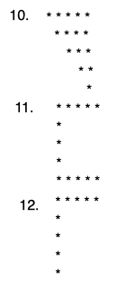**Pattern Programs:**

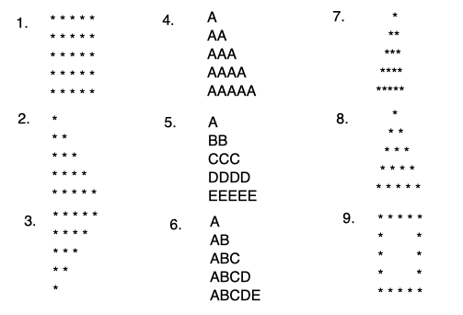

**Selenium Assignments:**

1. Automate the below scenario
   1. Test URL: http://automationpractice.com/
   2. Steps to be carried out
   3. Access the test URL
   4. Click on EVENING DRESSES in submenu that shows up for hover on Dresses menu
   5. Add Printed Dress product to the cart with following details

Quantity: 2, Size: L, Color: Pink

* 1. Click on Continue shopping button on window that shows after adding product to the cart
  2. Click on Women in the menu option
  3. Iterate through the products in the page to find out existence of product with name "Printed Chiffon Dress"
  4. If product exists then Hover on the product image and then click on Add to cart button or else print an exception, move to Cart and continue from Step 9
  5. Click on Proceed to checkout button in the window that opens up
  6. Reduce the quantity of Printed Dress in the Shopping cart - Summary tab and then proceed to next tab
  7. On sign in tab, Create a new account (Fill mandatory details only)
  8. On address tab, proceed to the next tab
  9. On shipping tab, Tick checkbox for Terms of Service and proceed to the next tab
  10. On payment tab, click on Pay by bank wire
  11. Click on I confirm my order button
  12. Capture the Order reference and amount shown on the Order Confirmation screen
  13. Navigate to ORDER HISTORY AND DETAILS under View my customer account (next to Sign out)
  14. Verify the newly created order exists in the Order History table
  15. Verify the Total price for order in table matches with the one captured on Order Confirmation screen
  16. Sign out of the application

1. Automate below scenario
   1. Navigate to <https://demo.openmrs.org/openmrs/>
   2. Enter credentials Admin/Admin123
   3. Click on in-patient ward
   4. Register a patient
   5. Search for the registered patient with the help of the patient id
   6. Click on the patient record
   7. Delete the respective patient
   8. Now search for the patient registered in step d
   9. Logout